Given a binary tree root, a ZigZag path for a binary tree is defined as follow:

* Choose **any**node in the binary tree and a direction (right or left).
* If the current direction is right then move to the right child of the current node otherwise move to the left child.
* Change the direction from right to left or right to left.
* Repeat the second and third step until you can't move in the tree.

Zigzag length is defined as the number of nodes visited - 1. (A single node has a length of 0).

Return the longest **ZigZag** path contained in that tree.

**Example 1:**

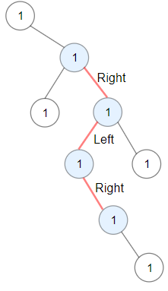

**Input:** root = [1,null,1,1,1,null,null,1,1,null,1,null,null,null,1,null,1]

**Output:** 3

**Explanation:** Longest ZigZag path in blue nodes (right -> left -> right).

**Example 2:**

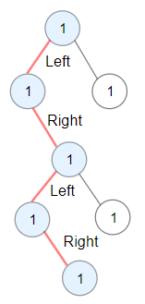

**Input:** root = [1,1,1,null,1,null,null,1,1,null,1]

**Output:** 4

**Explanation:** Longest ZigZag path in blue nodes (left -> right -> left -> right).

**Example 3:**

**Input:** root = [1]

**Output:** 0

**Constraints:**

* Each tree has at most 50000 nodes..
* Each node's value is between [1, 100].